Convert Oculus images to MPEG videos

|  |
| --- |
| >> pathName = 'Q:\ENG\Technical\underwater communications\Blutonomy\Tests & Trials\'  >> cfg.DR = [-60 0]; cfg.scaling=2; cfg.axisSquare=1; cfg.map=copper; cfg.swapBytes = 1;  >> sonar2movie(pathName,[],cfg); |

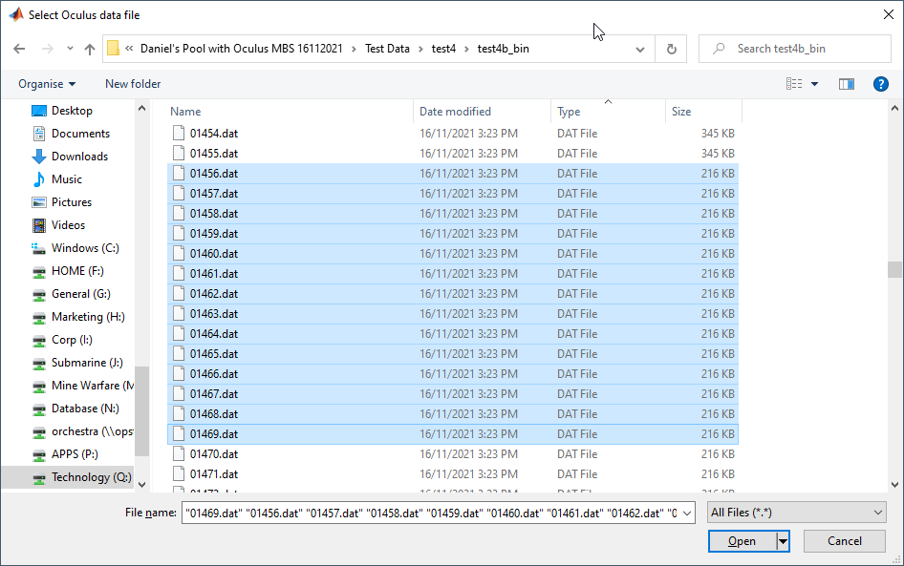

Matlab command window

|  |
| --- |
| nFiles =  14  .Processing file=01456.dat  header =  struct with fields:  fileVersion: 2  header =  struct with fields:  fileVersion: 2  speedOfSoundUsed: 1.5237e+03  frequency: 2.0989e+06  temperature: 20.3500  pressure: 0.0763  heading: 107.8750  pitch: 9.6250  roll: -5.8125  pingStartTime: 1.3826e+03  range: 5  gain: 97  rangeResolution: 0.0116  msSinceEpoch: 133  DateTime: 01/01/70 00:00:00.133  pingId: 1856  dataSize: 220160  rangeCount: 430  beamCount: 256  freqMode: 2  fileName =  'Q:\ENG\Technical\underwater communications\Blutonomy\Tests & Trials\Daniel's Pool with Oculus MBS 16112021\Test Data\test4\test4b_bin\01456.png' |

Creates a MPEG file in Matlab directory

oculus.mp4

